
Lovely Professional University
Phagwara, Punjab, India

School of Computer Science & Engineering
CSE 316 — Operating Systems
PROJECT REPORT
(Project Semester: January – May 2026)

Thread Synchronization Visualizer
An Interactive Web-Based OS Concurrency Education Tool

Submitted by

Name | Mac Tanatswa Muza
Registration No. | 12405348
Programme | B.Tech (Computer Science & Engineering)
Course Code | CSE 316

Under the Guidance of

Vikas Sharma
Discipline of Computer Science & Engineering

Lovely Professional University, Phagwara, Punjab

Certificate
This is to certify that Mac Tanatswa Muza, bearing Registration No. 12405348, has satisfactorily completed the CSE 316 project titled:

"Thread Synchronization Visualizer"
under my guidance and supervision. To the best of my knowledge, the present work is the result of the student's original development, effort, and study. This work has not been submitted elsewhere for any other degree or diploma.

Signature of Supervisor: ____________________ Date: _______________

[Faculty Name]
[Designation]
School of Computer Science and Engineering, Lovely Professional University

Declaration
I, Mac Tanatswa Muza, student of B.Tech (CSE) under the Discipline of Computer Science and Engineering at Lovely Professional University, Punjab, hereby declare that all the information furnished in this project report is based on my own intensive work and is genuine. The project titled "Thread Synchronization Visualizer" has been developed entirely by me and has not been submitted for any other examination or award at this or any other institution.

Signature: ____________________ Date: _______________

Name: Mac Tanatswa Muza
Registration No.: 12405348

Acknowledgement
I would like to express my sincere gratitude to all those who contributed to the successful completion of this project. First and foremost, I am deeply thankful to my faculty guide for providing continuous guidance, motivation, and valuable feedback throughout the development of this work. Their insights into Operating System concepts helped shape the direction of this project significantly.
I also extend my thanks to the Department of Computer Science and Engineering at Lovely Professional University for providing the necessary resources and academic environment. The open-source tools and libraries used in this project — including React, Vite, and Tailwind CSS — greatly simplified the development process, and I appreciate the communities that built and maintain them.
Finally, I thank my peers for their constructive feedback during the testing phase, which helped improve the overall usability and correctness of the visualizer.

Table of Contents
1. Introduction
2. Objectives and Scope
3. Technology Stack and System Architecture
4. Module-Wise Component Breakdown
5. Core Functionalities
6. Application Flow Diagram and Architecture
7. Module Analysis — Counting Semaphore
7.1 Introduction to the Counting Semaphore
7.2 General Description
7.3 Functional Requirements and Key Logic
7.4 Simulation Results and Visualisation
8. Module Analysis — Mutex (Mutual Exclusion Lock)
9. Module Analysis — Monitor (Bounded Buffer)
10. Module Analysis — Dining Philosophers Problem
11. List of Analyses with Results
12. GitHub and Deployment
13. Conclusion and Future Scope
14. References
Appendix A. Problem Statement
Appendix B. Deep Architectural Analysis
Appendix C. Complete Algorithm Reference

1. Introduction
Operating Systems form the backbone of modern computing. At their core, OS primitives — mechanisms such as semaphores, mutexes, and monitors — are what allow multiple threads and processes to share resources without corrupting shared state. Traditional academic resources, including textbooks and static diagrams, often fail to convey the dynamic, time-dependent nature of thread synchronisation; students frequently understand the theory without developing intuitive insight into runtime behaviour.
This project presents the Thread Synchronization Visualizer, an interactive, browser-based educational tool developed for CSE 316 (Operating Systems). The application allows a student or instructor to simulate and observe the real-time behaviour of four key OS synchronisation primitives:
- Counting Semaphore — limiting concurrent thread access to N configurable slots.
- Mutex (Mutual Exclusion Lock) — enforcing single-owner access with FIFO wake order.
- Monitor with Bounded Buffer — producer/consumer coordination via condition variables.
- Dining Philosophers — classic deadlock/starvation scenario with back-off livelock prevention.
The application is built entirely on the client side as a Single Page Application (SPA) using React 18, Vite 5, and Tailwind CSS. It requires no backend server, making it trivial to deploy and share. The live version is accessible at https://thread-sync-visualizer.vercel.app.
The visualizer provides colour-coded thread state indicators (Running, Waiting, Blocked), real-time log output, adjustable simulation speed, and configurable thread/resource counts — all of which make it a rich learning tool for understanding concurrency.

2. Objectives and Scope

2.1 Objectives
- To design and implement a visually interactive simulator for OS-level synchronisation primitives.
- To provide real-time, animated visualisations of thread state transitions (Running, Waiting, Blocked).
- To demonstrate the behaviour of semaphores, mutexes, monitors, and the Dining Philosophers problem through configurable simulations.
- To allow users to observe threads transitioning between active, waiting, and blocked states in real time.
- To demonstrate how synchronisation primitives manage shared resource allocation.
- To empower users to dynamically alter system parameters — thread count, simulation speed, and buffer sizes — and study their effects on system behaviour.
- To provide a time-stamped event log that mirrors what a real OS scheduler would produce.
- To deliver a fully client-side, zero-backend tool deployable on static hosts such as Vercel, Netlify, or GitHub Pages.

2.2 Scope
The project is scoped to the simulation of four classical OS synchronisation modules. Each module is self-contained and can be run independently. The scope does not include actual OS-level threading (e.g., pthreads or kernel threads); instead, all simulation is driven by a deterministic JavaScript timer engine that models thread behaviour logically.
The simulation engine supports configurable parameters: number of threads (2–8), semaphore capacity (1–5), number of producers/consumers (1–4), and simulation speed (0.5× to 4×) via a real-time slider.

3. Technology Stack and System Architecture

3.1 Programming Languages
Language | Role
JavaScript (JSX) | Primary language for all application logic, state management, and UI rendering.
HTML5 / CSS3 | Structural markup and base styling, managed through Tailwind CSS utility classes.

3.2 Libraries and Frameworks
Technology | Version | Purpose
React | 18.x | Component-based UI framework; Hooks for state management.
Vite | 5.x | Fast build tool and dev server; enables HMR during development.
Tailwind CSS | 3.x | Utility-first CSS framework for rapid, consistent UI design.
Framer Motion | 11.x | Animation library for smooth tab transitions and state changes.
React Hooks | --- | useState, useRef, useCallback — simulation state and render optimisation.

3.3 Deployment and Build Tools
Tool | Purpose
GitHub Pages / Vercel / Netlify | Supported static deployment targets. No server infrastructure required.
Browser Runtime | Entire simulation engine runs natively in the browser via setTimeout loops.
Vite Build | Generates optimised static artefacts via npm run build. Output served from /dist.

3.4 Component Architecture
The application is structured as a single-page React application (SPA). The root App component maintains the active tab state and renders the appropriate section component using React's AnimatePresence from Framer Motion for smooth transitions. Each simulation module is a fully self-contained component:
- SemaphoreSection.jsx — Counting semaphore state, slots, and FIFO wait queue.
- MutexSection.jsx — Lock ownership, FIFO blocked queue, thread cards.
- MonitorSection.jsx — Bounded buffer, condition variable bars, producer/consumer roles.
- DiningPhilosophers.jsx — Circular table diagram, fork ownership panel, philosopher states.
- useSimulationEngine.js — Shared hook for timer management and speed control.
- ThreadCard.jsx / Controls.jsx / LogBox.jsx — Reusable UI primitives shared across all modules.
The entire application runs on the client side. No API calls are made and no data is stored server-side.

4. Module-Wise Component Breakdown

4.1 Application Shell — App.jsx
The root component of the SPA. It is responsible for top-level routing (managed via simple tab state), rendering the navigation header, and conditionally mounting one of the four simulation modules. It acts as the orchestrator that ties the entire application together, maintaining the active tab in useState and using Framer Motion's AnimatePresence to animate between module views.

4.2 Semaphore Module — SemaphoreSection.jsx
Demonstrates the behaviour of a Counting Semaphore. This module allows up to N concurrent threads to access a shared resource simultaneously, where N is a user-configurable parameter.
Key Implementation Details:
- Maintains a slots variable representing the current semaphore count.
- Running threads decrement slots. Once slots < 1, additional requesting threads are pushed to a FIFO queue and their state changes to Blocked (visualised in red).
- Upon completion, a thread releases its slot, increments the semaphore, and the next queued thread is dequeued and activated.

4.3 Mutex Module — MutexSection.jsx
Demonstrates Mutual Exclusion (a Binary Semaphore / Lock). Only one thread can hold the lock at any time, enforcing strict ownership semantics.
Key Implementation Details:
- Tracks state as lockState({ locked: boolean, owner: thread_id }) instead of a simple counter.
- The UI visually highlights the current lock owner, directly linking the active thread to the critical section.
- Threads that attempt to acquire an already-locked mutex are placed in a FIFO queue.
- A visual event log explicitly tracks all lock() and unlock() operations with timestamps.

4.4 Monitor Module — MonitorSection.jsx
Demonstrates the classic Bounded Buffer (Producer–Consumer) problem using a Monitor construct. It encapsulates shared state, a mutex, and two condition variables.
Key Implementation Details:
- Threads are statically assigned roles as either Producers or Consumers.
- Producers push integers to the buffer. If buffer capacity (BUFFER_CAP) is reached, they call wait(notFull) and enter the notFullQ.
- Consumers pop integers from the buffer. If the buffer is empty, they call wait(notEmpty) and enter the notEmptyQ.
- After consuming, consumers signal(notFull). After producing, producers signal(notEmpty) — implementing the classic monitor signalling protocol.

4.5 Dining Philosophers — DiningPhilosophers.jsx
Implements the classic Dining Philosophers problem with a circular table SVG diagram and a fork ownership status panel. Each philosopher is modelled as a finite state machine cycling through Thinking, Hungry, and Eating states. Fork ownership is managed as a mutex array of length 5, and the back-off strategy prevents circular wait.

4.6 Global Event Log — LogBox
A passive, read-only component that observes all thread state transitions across all modules. It displays a chronological feed of formatted log entries (e.g., T3 dequeued → running (sem=1)), giving users full insight into the execution order of the algorithm.

5. Core Functionalities

5.1 Simulation Features
- Real-time thread lifecycle visualisation: threads cycle through Waiting (yellow), Blocked (red), and Running (green) states.
- Counting Semaphore simulation with configurable concurrent access slots.
- Mutual Exclusion Lock simulation with explicit owner tracking and FIFO queuing.
- Producer–Consumer Monitor simulation with bounded buffer and dual condition variables.
- Dining Philosophers simulation with back-off deadlock prevention.
- Chronological Event Log capturing every state transition with contextual metadata.

5.2 User Control Features
- Play / Pause the simulation at any time without losing current state.
- Reset the entire simulation to its initial state.
- Dynamically adjust Simulation Speed (0.5× to 4×) using the speed slider.
- Modify thread count, buffer capacity, and semaphore slot count on-the-fly.
- Seamlessly switch between the four algorithm tabs.

5.3 UI and Visual Features
- Dark-mode interface with consistent colour-coded status indicators.
- Thread Cards showing thread ID, live status badge, and animated progress bar.
- System Dashboard with contextual visualisations: circular slot indicators for Semaphores, padlock icons for Mutexes, and filling array blocks for Monitor buffers.
- Circular table SVG diagram for the Dining Philosophers problem with animated fork connection lines.

6. Application Flow Diagram and Architecture

6.1 End-to-End Application Pipeline
The following diagram illustrates the complete execution flow of the application, from user input through to the rendered React UI. It forms the core simulation pipeline and shows how a single thread progresses through its lifecycle within any module.

+------------------------------------------------------------------+
| THREAD SYNCHRONIZATION VISUALIZER |
| APPLICATION PIPELINE |
+------------------------------------------------------------------+

[User Opens App]
|
v
[App.jsx Renders]
|
+----> [Tab: Semaphore | Mutex | Monitor | Dining Philosophers]
|
v
+---------------------------------------------------+
| Control Panel |
| Play/Pause | Reset | Speed Slider | Thread Count |
+---------------------------------------------------+
|
v
[Simulation Loop: setTimeout( tick() )]
|
| +----------------------------------------------+
| | THREAD LIFECYCLE (FSM) |
| | |
| | [WAITING] ---> Tries to acquire resource |
| | (Yellow) |
| | | |
| | +---+---+ |
| | YES NO |
| | | | |
| | v v |
| | [RUNNING] [BLOCKED] --> Pushed to Queue |
| | (Green) (Red) |
| | | | |
| | | [Signal received --> dequeued] |
| | v v |
| | [Work Complete] <----------------------------+
| | |
| | v
| | [Release Resource / Signal Next Thread]
| | |
| | +---> [Back to WAITING]
| +----------------------------------------------+
|
v
[syncUI() -- copies stateRef snapshot into React uiState]
|
v
[React re-renders: Thread Cards + Dashboard + Log]
|
v
[LogBox records all transitions with timestamps]

6.2 Render-Simulation Decoupling Pattern
The most technically significant architectural decision in this project is the deliberate separation between the simulation engine and the React render cycle. This pattern resolves a fundamental tension in React: state updates trigger re-renders, but a high-frequency simulation loop would cause React to re-render dozens of times per second if simulation state were stored in useState.
The solution is a two-layer state architecture:
- Simulation State (useRef): All thread objects, queue arrays, semaphore counters, and lock states are stored in a mutable stateRef. Because useRef mutations do not trigger re-renders, the simulation loop can run at its own frequency — controlled by setTimeout — without React interference.
- UI State (useState): A separate uiState object holds only the data needed to paint the current frame. The syncUI() function periodically copies a snapshot of stateRef into uiState, triggering a controlled, batched React re-render.
This pattern is conceptually analogous to a game-engine loop: the physics engine (stateRef) runs independently of the frame renderer (React). It is an advanced React pattern that prevents performance degradation as thread counts scale up.

6.3 Thread State Machine
Every thread in the system is modelled as a finite state machine (FSM) with three states. The transition cycle is: WAITING --> (tries acquire) --> RUNNING (if resource available) or BLOCKED (otherwise) --> (signal/complete) --> back to WAITING. The transitions are governed by the specific synchronisation primitive being simulated, making the same visual framework applicable to all four modules.

6.4 Module Interaction Model
Each of the four modules is entirely self-contained. They share only the UI shell (App.jsx) and the LogBox component. There is no cross-module state — switching tabs pauses or resets the previous module and initialises the new one with fresh state.

7. Module Analysis — Counting Semaphore

7.1 Introduction
A semaphore is one of the most fundamental synchronisation primitives in operating systems, originally introduced by Dijkstra in 1965. A counting semaphore maintains an integer counter S representing the number of available resources or permits. Two atomic operations are defined: wait() (also called P or down), which decrements S and blocks the calling thread if S becomes negative; and signal() (also called V or up), which increments S and wakes a blocked thread if any are queued.
In this module, the semaphore is modelled with a user-configurable capacity N (1–5). Up to N threads may hold a semaphore slot simultaneously; any additional threads are placed in a wait queue.

7.2 General Description
The Semaphore module displays the current semaphore state including the number of available slots, the total capacity, and the wait queue. Each thread is represented by a ThreadCard that visually reflects its state. The simulation supports 2–8 threads and 1–5 semaphore slots.
Threads begin in the Waiting state and attempt to acquire a slot after a small random delay. If a slot is available, the thread transitions to Running for a randomly determined duration. Upon completion, it calls signal(), releasing its slot, at which point a blocked thread (if any) is dequeued and woken.

7.3 Functional Requirements and Key Logic
- Semaphore state: { count, capacity, waitQueue[] }.
- wait(): if count > 0, decrement and enter Running; else push to waitQueue and mark Blocked.
- signal(): if waitQueue is empty, increment count; else dequeue the first thread and mark it Running (count unchanged).
- Timer interval governed by useSimulationEngine.js, applying the user-selected speed multiplier.
- LogBox records every state transition with a timestamp in seconds since simulation start.
7.3.1 Semaphore Algorithm (Pseudocode)
// Thread requests resource -- wait() / P operation
if (stateRef.current.slots > 0) {
stateRef.current.slots--;
thread.state = 'running';
} else {
stateRef.current.queue.push(thread);
thread.state = 'blocked';
}

// Thread releases resource -- signal() / V operation
stateRef.current.slots++;
const next = stateRef.current.queue.shift();
if (next) {
next.state = 'running';
stateRef.current.slots--; // next thread immediately consumes slot
}

7.4 Simulation Results and Visualisation
Figures 7.1 and 7.2 show the semaphore simulation in its initial state and during an active run with 4 threads and a capacity of 2.

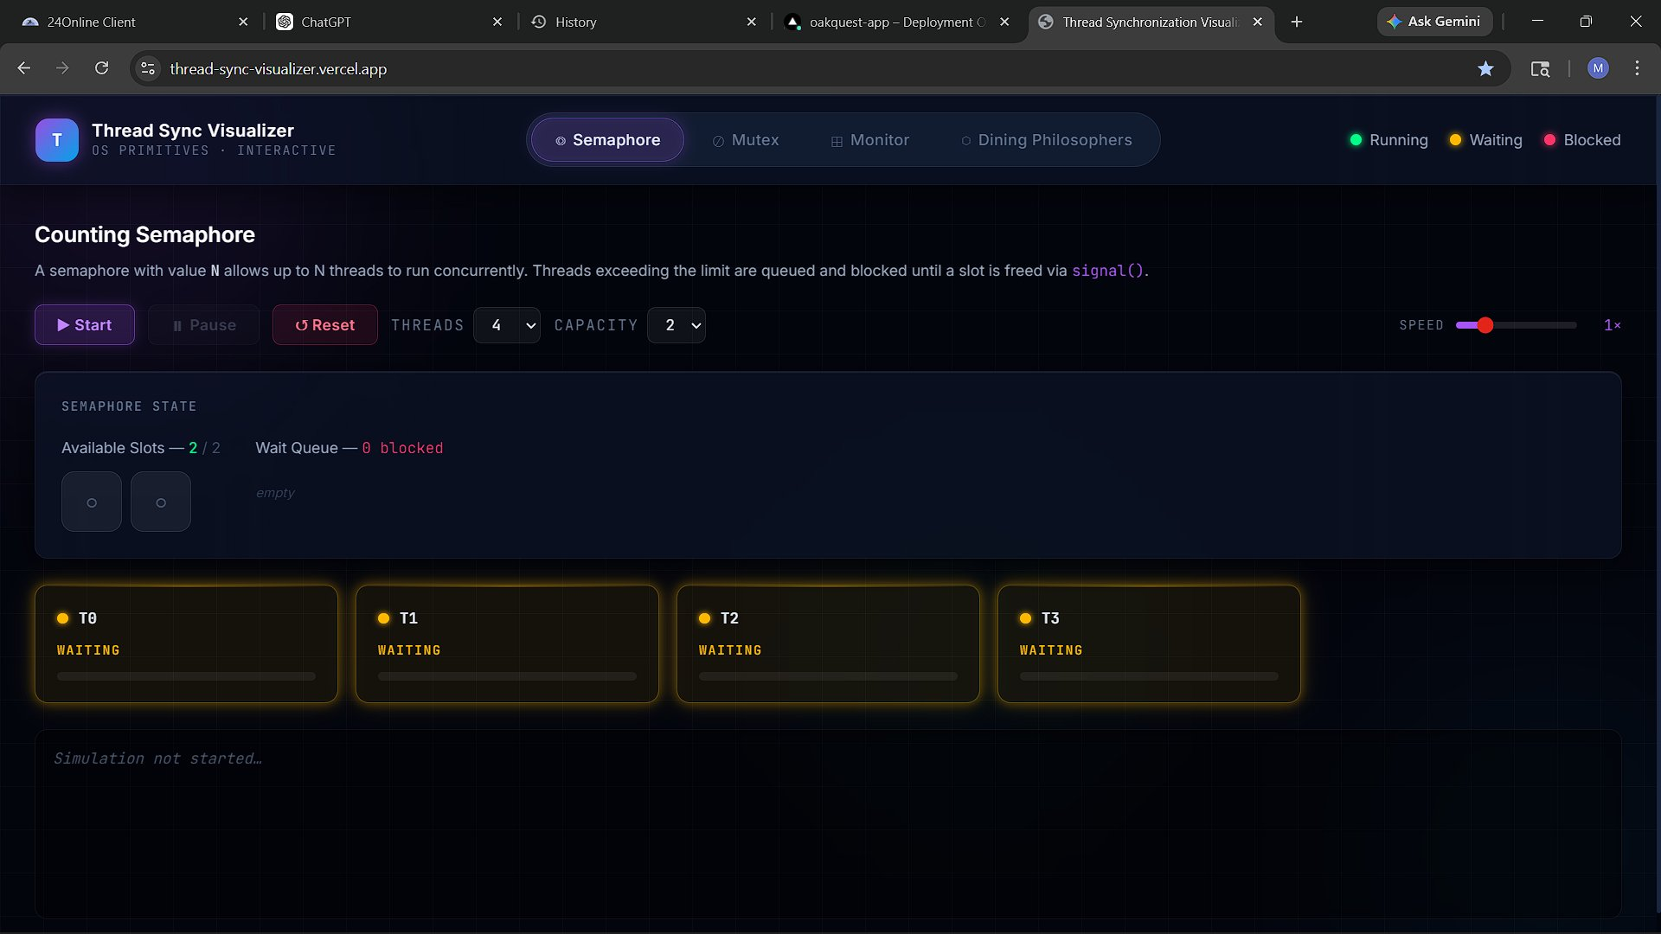
Figure 7.1 — Semaphore module: initial state (2 slots available, 4 threads in Waiting state, simulation not started).
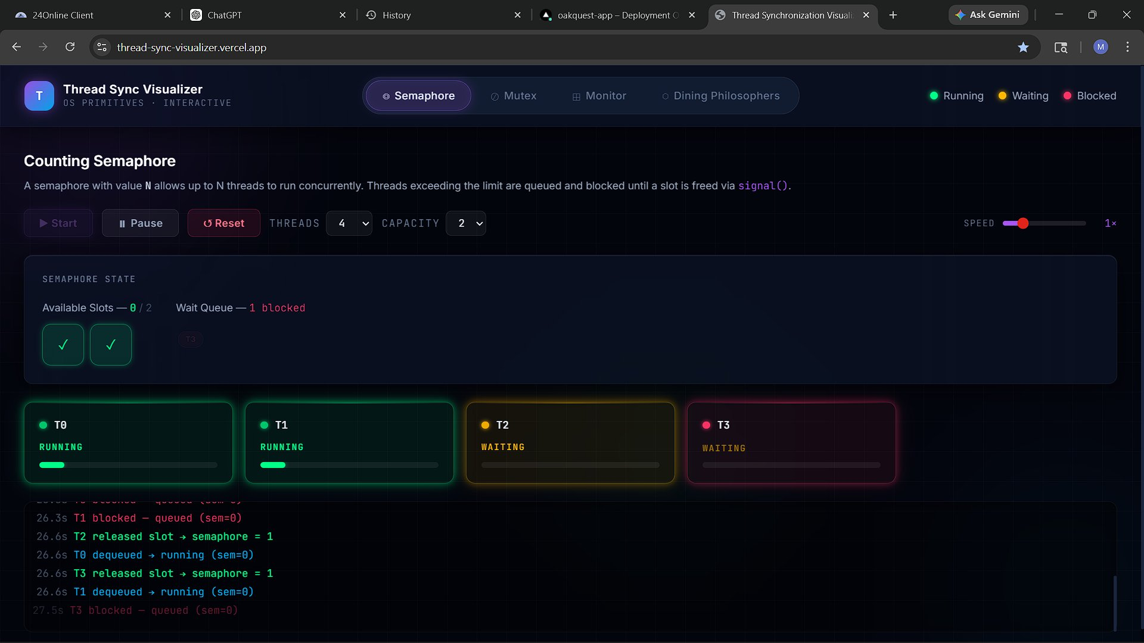
Figure 7.2 — Semaphore simulation running: T0 and T1 hold slots (Running); T2 and T3 are blocked in the FIFO wait queue. The event log records precise timestamps.
As observed in Figure 7.2, when both semaphore slots are occupied (T0 and T1 are Running), threads T2 and T3 are placed in the wait queue and shown as Blocked. The log panel records the precise timestamps at which each thread was blocked, dequeued, and ran.

8. Module Analysis — Mutex (Mutual Exclusion Lock)

8.1 Introduction
A mutex (mutual exclusion lock) is a binary semaphore with ownership semantics. Unlike a general semaphore, a mutex can only be released by the thread that acquired it. This ownership constraint prevents bugs such as priority inversion and double-release errors. In most real OS implementations (e.g., POSIX pthread_mutex), the mutex maintains a queue of blocked threads and wakes them in FIFO order to ensure fairness.
This module simulates a single mutex shared among N configurable threads (2–8). The mutex enforces single ownership at any time and maintains a FIFO contention queue for all threads that attempt to acquire the lock while it is held.

8.2 General Description
The Mutex module renders the current lock state (UNLOCKED/LOCKED), the identity of the current owner thread, and the FIFO queue of blocked threads. The owning thread's ThreadCard is highlighted with a green border and labelled OWNER. Threads in the FIFO queue are shown as Blocked with their queue order displayed visually.

8.3 Functional Requirements and Key Logic
- Mutex state: { locked: bool, owner: threadId|null, fifoQueue: [] }.
- lock(): if locked is false, caller becomes owner and locked <- true; else push to fifoQueue and mark Blocked.
- unlock(): set locked <- false, owner <- null; if fifoQueue non-empty, dequeue first thread and grant lock immediately (FIFO wake semantics).
- A "TO HOLDS LOCK" badge identifies the next thread in queue to receive the lock.
- All events are logged: [time]s [thread] acquired/released/blocked mutex.
8.3.1 Mutex Algorithm (Pseudocode)
// Thread calls lock()
if (!stateRef.current.lockState.locked) {
stateRef.current.lockState.locked = true;
stateRef.current.lockState.owner = thread.id;
thread.state = 'running';
} else {
stateRef.current.fifoQueue.push(thread);
thread.state = 'blocked';
}

// Thread calls unlock()
stateRef.current.lockState.locked = false;
stateRef.current.lockState.owner = null;
const next = stateRef.current.fifoQueue.shift();
if (next) {
stateRef.current.lockState.locked = true; // FIFO wake
stateRef.current.lockState.owner = next.id;
next.state = 'running';
}

8.4 Simulation Results and Visualisation
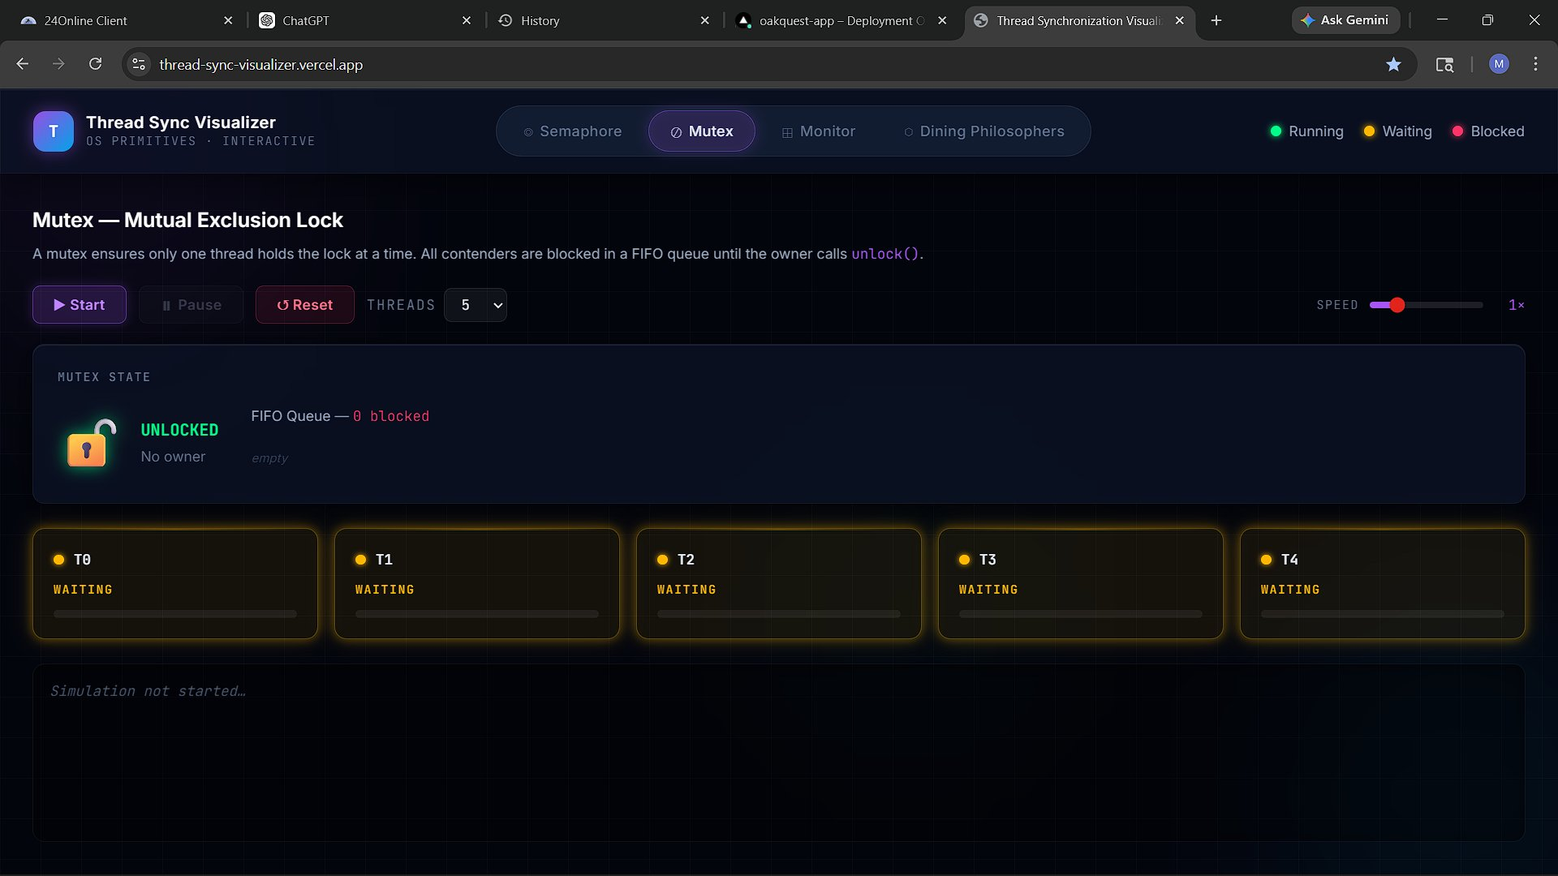
Figure 8.1 — Mutex module: initial state (unlocked, 5 threads in Waiting state, no owner).
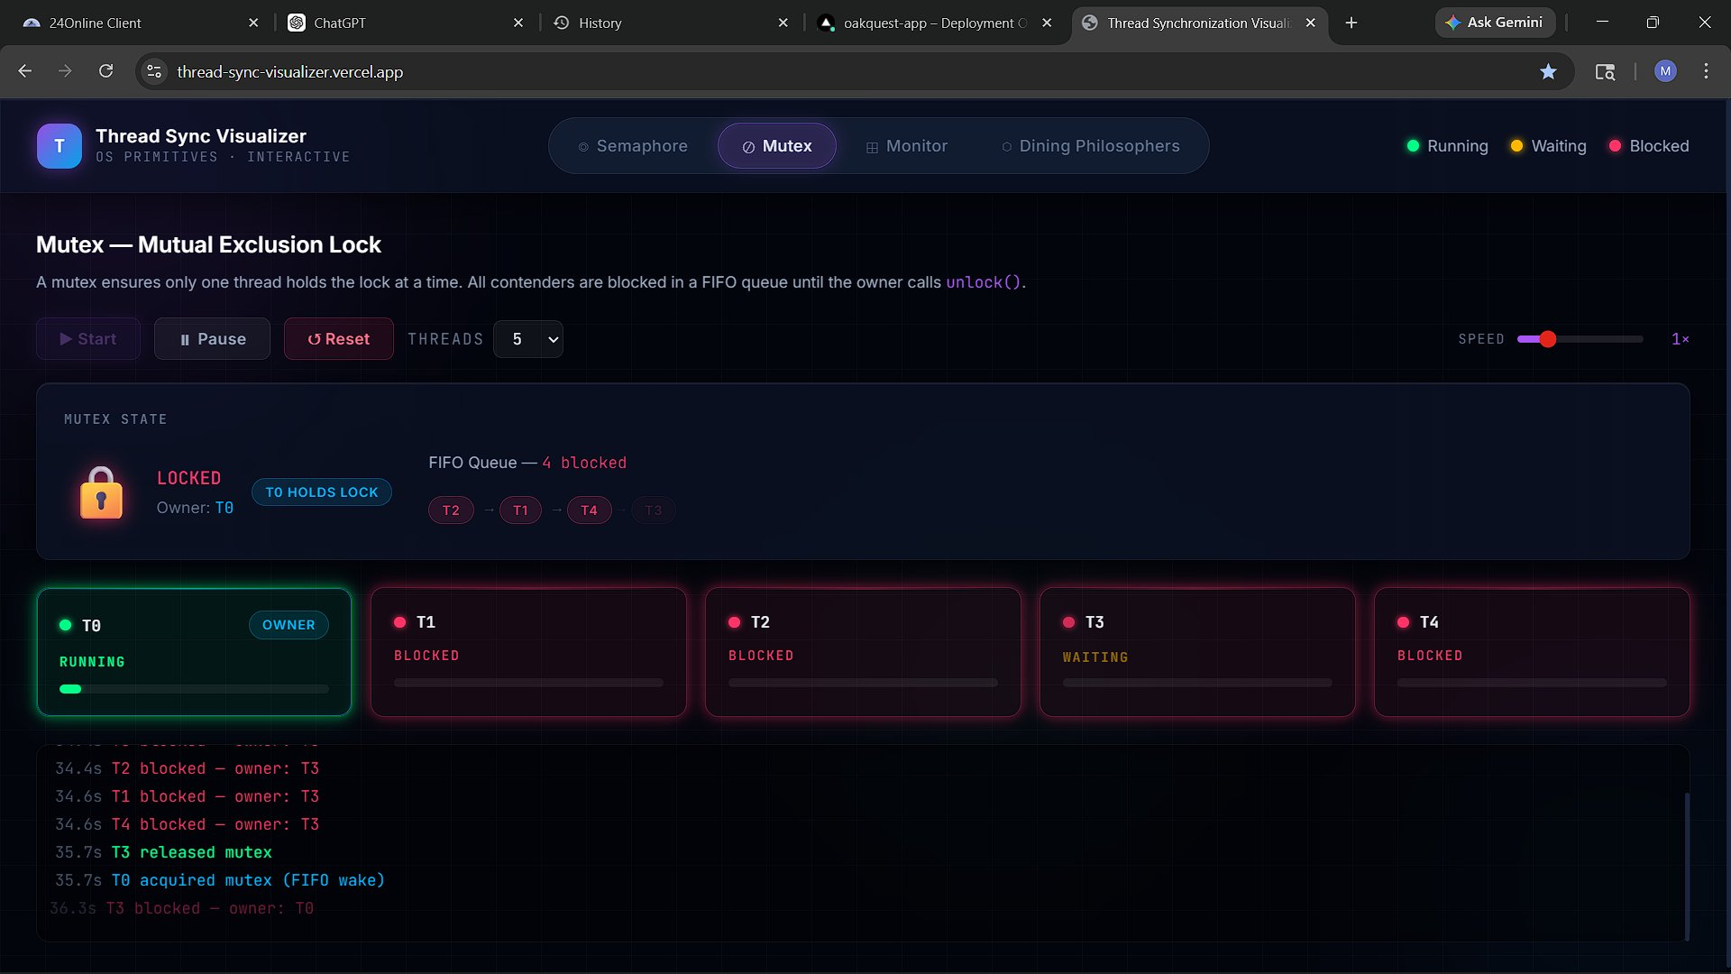
Figure 8.2 — Mutex simulation running: T0 holds the lock (owner, Running); T1, T2, and T4 are blocked in FIFO order. The event log confirms T3 released and T0 was woken via FIFO wake semantics.
Figure 8.2 clearly illustrates the FIFO queue mechanism. T0 holds the lock (Running) while T1, T2, and T4 are blocked and listed in queue order. The log entries confirm that T3 released the mutex, triggering a FIFO wake that granted the lock to T0.

9. Module Analysis — Monitor (Bounded Buffer)

9.1 Introduction
A monitor is a high-level synchronisation construct that encapsulates shared state, a mutex, and one or more condition variables into a single abstraction. Monitors were introduced by Hoare and refined by Hansen as a more structured alternative to raw semaphore programming. The key insight is that all access to shared data is serialised by the monitor's internal mutex, and threads can wait on condition variables without releasing the outer lock improperly.
This module implements the classic Bounded Buffer (Producer–Consumer) problem using a monitor. Two condition variables — notFull and notEmpty — govern when producers and consumers may proceed.

9.2 General Description
The Monitor module displays the shared buffer (capacity 4), a bar indicator for each condition variable (showing the relative number of waiters), and ThreadCards for all producer and consumer threads. The monitor lock state appears in the top-right corner (LOCK FREE or LOCKED — [owner]).
Producers generate a random integer value and attempt to add it to the buffer. If the buffer is full, they call wait(notFull), suspending them and releasing the monitor lock. Consumers attempt to remove an item; if the buffer is empty, they call wait(notEmpty). A successful produce triggers signal(notEmpty); a successful consume triggers signal(notFull).

9.3 Functional Requirements and Key Logic
- Buffer state: { items: [], capacity: 4 }.
- Monitor lock: single mutex governing entry into the monitor.
- notFull condition variable: producers wait here when buffer is at capacity.
- notEmpty condition variable: consumers wait here when buffer is empty.
- produce(): acquire lock -> if full, wait(notFull) -> insert item -> signal(notEmpty) -> release lock.
- consume(): acquire lock -> if empty, wait(notEmpty) -> remove item -> signal(notFull) -> release lock.
- Buffer slots rendered as numbered cells; filled cells display the produced value.
- Configurable: 1–4 producers, 1–4 consumers.
9.3.1 Monitor Producer/Consumer Algorithm (Pseudocode)
// Producer thread
if (buffer.length >= BUFFER_CAP) {
thread.state = 'blocked';
notFullQ.push(thread); // wait(notFull)
} else {
buffer.push(produce());
const consumer = notEmptyQ.shift();
if (consumer) consumer.state = 'running'; // signal(notEmpty)
}

// Consumer thread
if (buffer.length === 0) {
thread.state = 'blocked';
notEmptyQ.push(thread); // wait(notEmpty)
} else {
buffer.shift();
const producer = notFullQ.shift();
if (producer) producer.state = 'running'; // signal(notFull)
}

9.4 Simulation Results and Visualisation
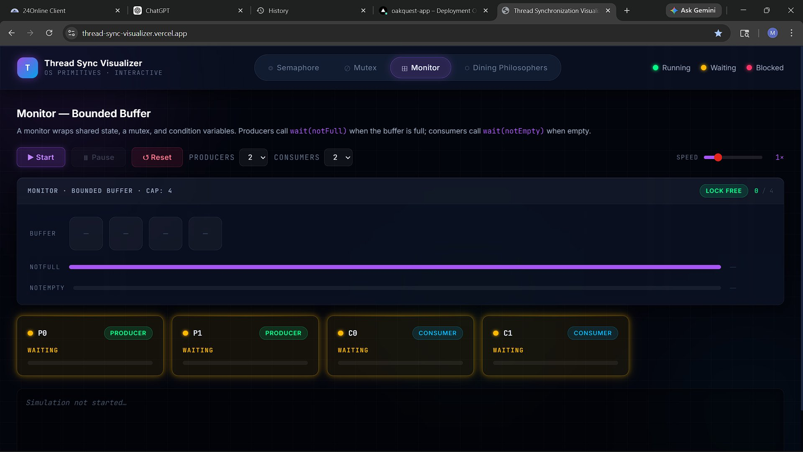
Figure 9.1 — Monitor module: initial state (empty buffer, 2 producers and 2 consumers waiting, lock free).
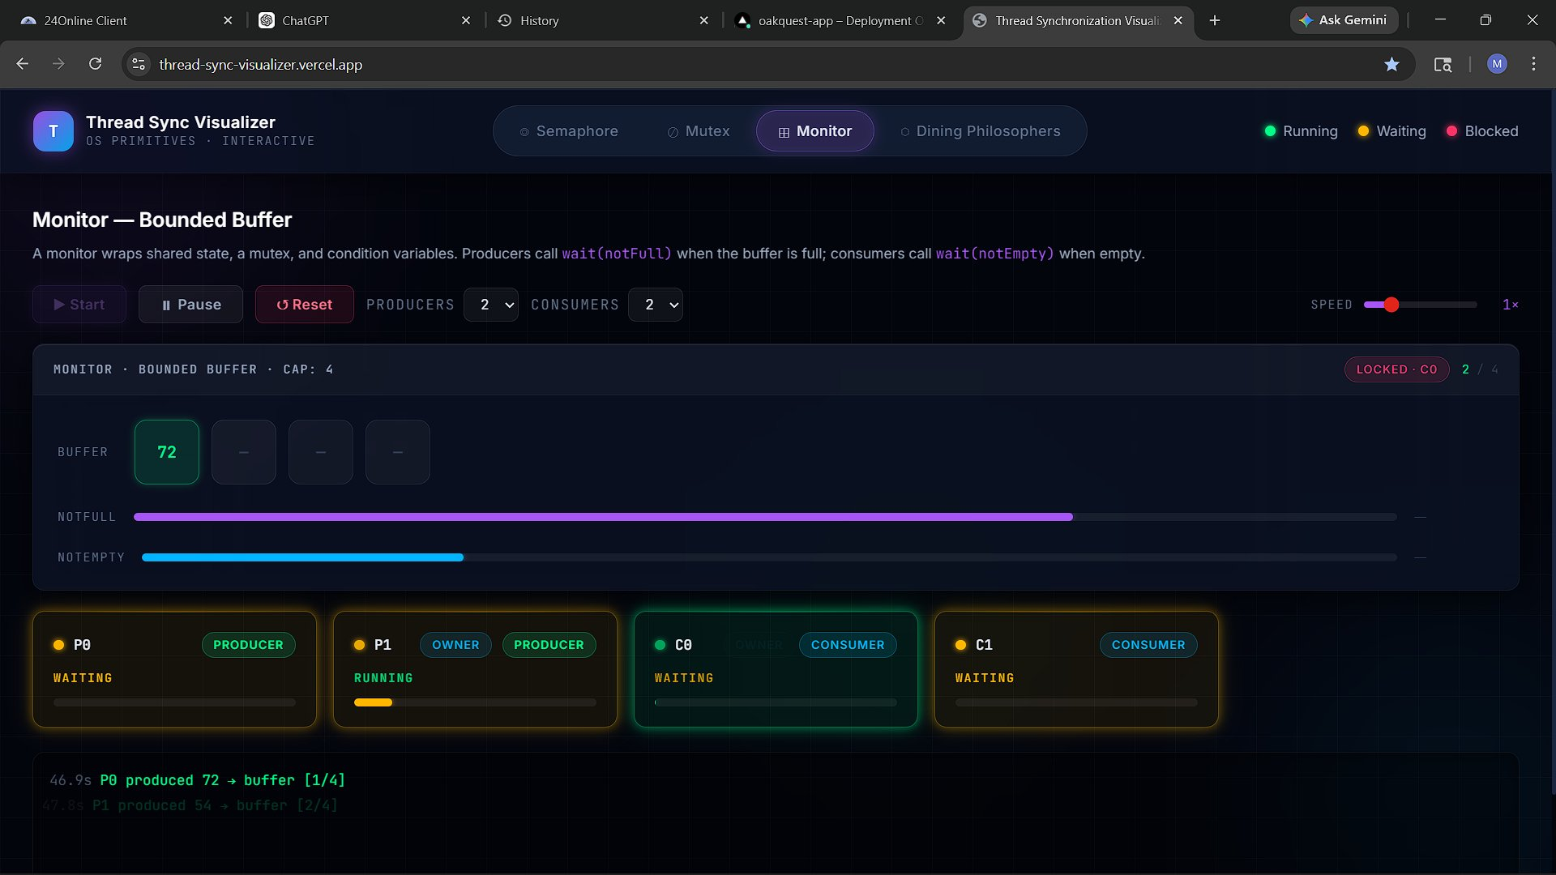
Figure 9.2 — Monitor simulation running: P1 holds the monitor lock (owner); buffer contains 2 items; the notEmpty condition bar is partially filled indicating a consumer has been signalled.
Figure 9.2 shows an active simulation in which P1 holds the monitor lock and has produced item 72 into slot 1. The notEmpty bar is partially filled, indicating a consumer has been signalled and is ready to consume. The event log confirms the sequence of produce operations.

10. Module Analysis — Dining Philosophers Problem

10.1 Introduction
The Dining Philosophers problem, formulated by Dijkstra in 1965, is a classical illustration of the challenges of resource allocation and deadlock avoidance in concurrent systems. Five philosophers sit at a circular table, alternating between thinking and eating. Each philosopher requires two adjacent forks (mutexes) to eat. If all five philosophers simultaneously pick up their left fork, a circular wait is formed and no philosopher can ever eat — a deadlock.
This module simulates the problem and demonstrates the back-off strategy (related to the Chandy/Misra solution) that prevents both deadlock and livelock.

10.2 General Description
The module renders two panels: a circular table SVG diagram (left) showing philosophers and forks with animated connection lines, and a Fork Ownership panel and philosopher status cards (right). Each philosopher cycles through three states: Thinking (grey), Hungry (yellow, attempting to acquire forks), and Eating (green, holding both forks).

10.3 Deadlock Prevention — Back-off Strategy
- A hungry philosopher first attempts to acquire its left fork (mutex).
- It then attempts to acquire its right fork.
- If the right fork is unavailable, the philosopher releases the left fork and retries after a random back-off delay.
- This breaks the circular wait condition: a philosopher holding one fork will release it rather than waiting indefinitely.
The random delay prevents livelock by ensuring that on average at least one philosopher will successfully acquire both forks in any given cycle.
10.3.1 Dining Philosophers Algorithm (Pseudocode)
function tryToEat(philosopher) {
const left = philosopher.id;
const right = (philosopher.id + 1) % NUM_PHILOSOPHERS;

// Attempt to acquire left fork
if (!forks[left].locked) {
forks[left].locked = true;
forks[left].owner = philosopher.id;

// Attempt to acquire right fork
if (!forks[right].locked) {
forks[right].locked = true;
forks[right].owner = philosopher.id;
philosopher.state = 'eating'; // both forks acquired
} else {
// Back-off: release left fork and retry after random delay
forks[left].locked = false;
forks[left].owner = null;
philosopher.state = 'hungry';
scheduleRetry(philosopher, randomDelay());
}
}
}

10.4 Simulation Results and Visualisation
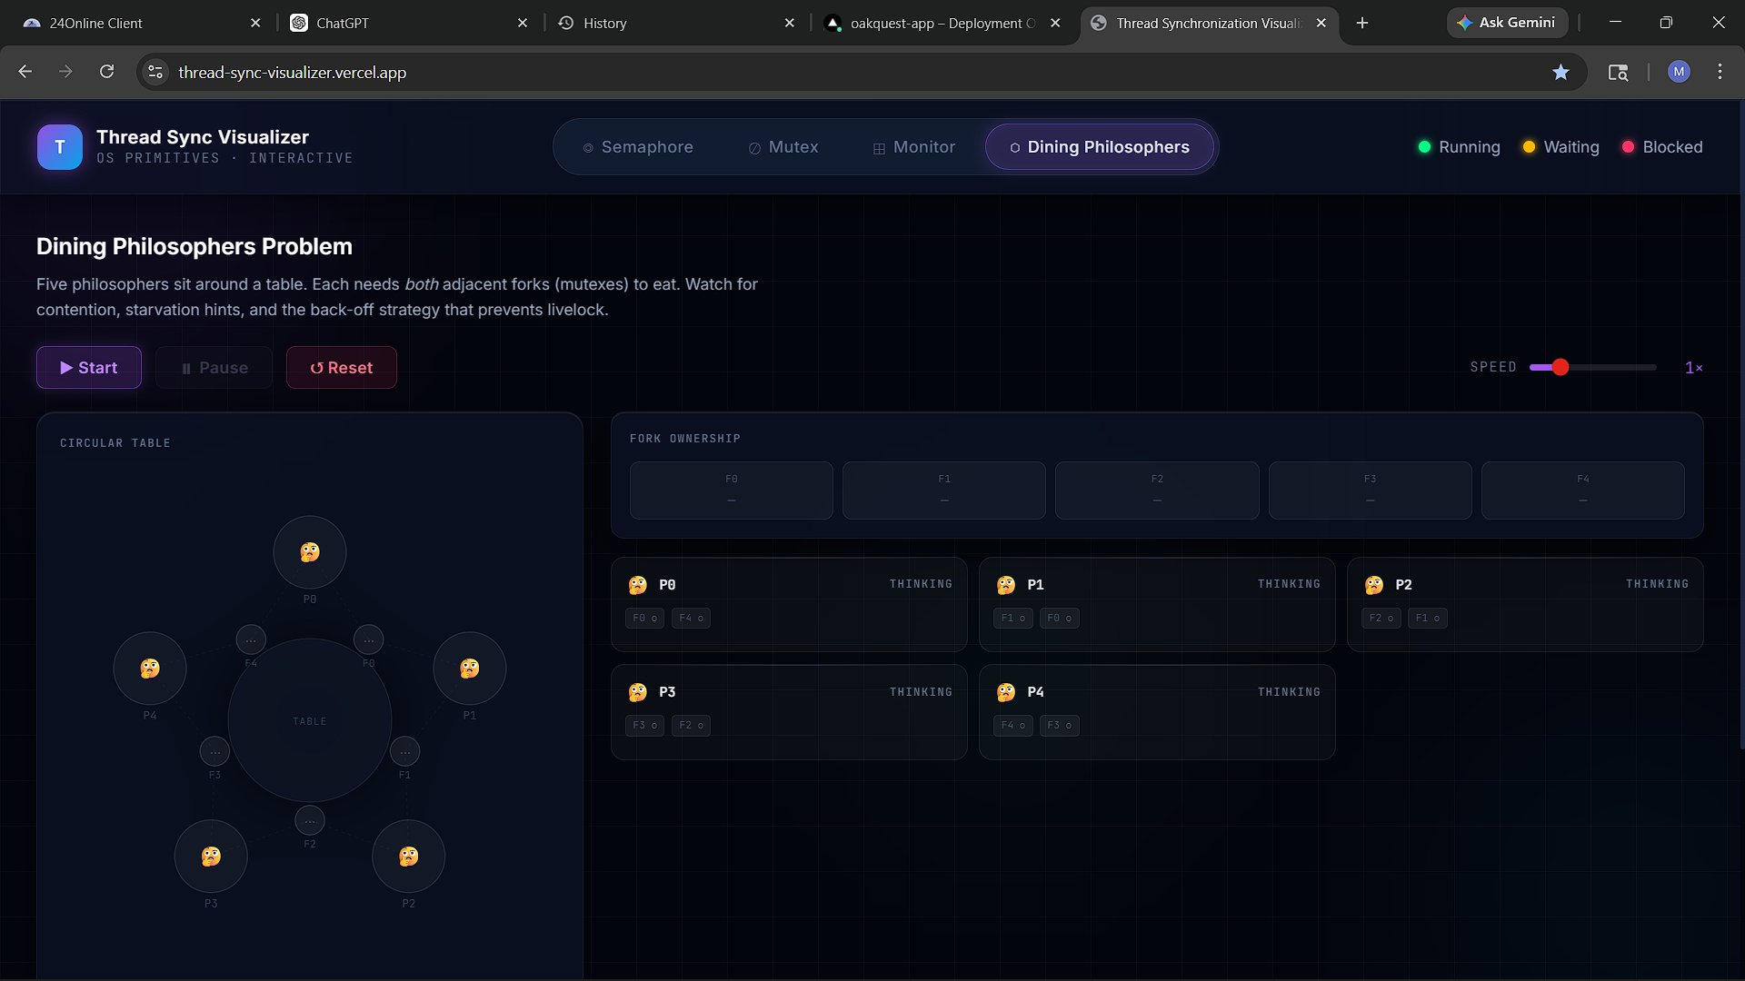
Figure 10.1 — Dining Philosophers: initial state (all five philosophers in Thinking state; all five forks free).
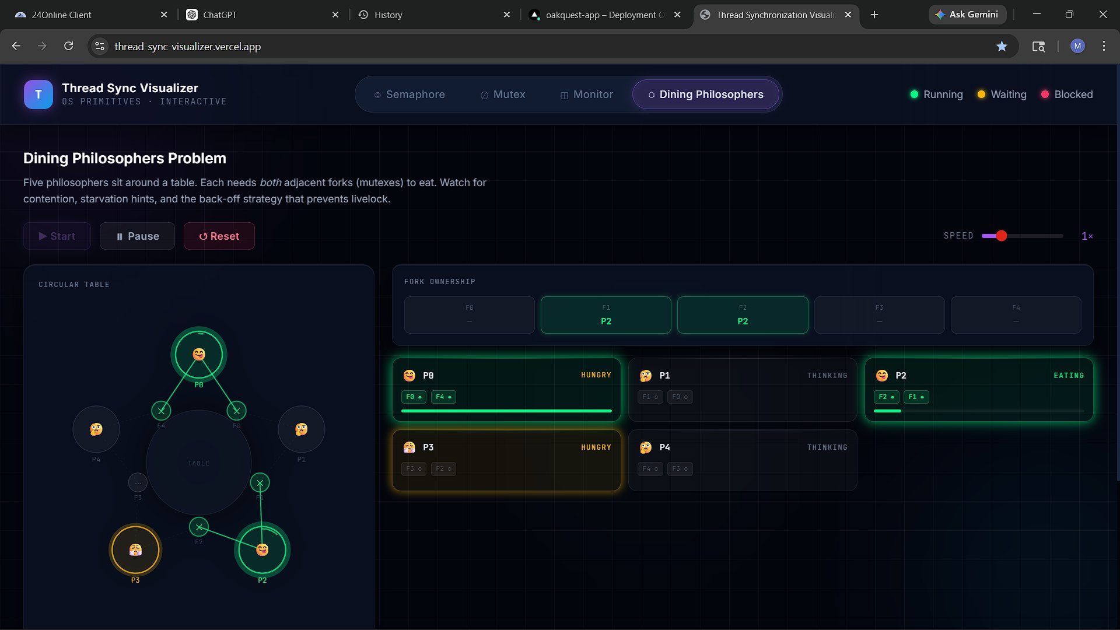
Figure 10.2 — Dining Philosophers simulation running: P2 is Eating (holding F1 and F2, highlighted in the Fork Ownership panel); P0 and P3 are Hungry but blocked pending fork availability.
Figure 10.2 illustrates a typical simulation snapshot. Philosopher P2 holds forks F1 and F2. Philosophers P0 and P3 are Hungry but cannot eat as their required forks are occupied. The back-off strategy ensures that all philosophers eventually eat over time and no deadlock occurs.

11. List of Analyses with Results
The following table summarises the results of each module simulation conducted during the development and testing phase of the project.

Module | Primitive Type | Key Parameter | Key Observation
Semaphore | Counting Semaphore | Capacity = 2, Threads = 4 | 2 threads run concurrently; 2 are blocked. FIFO dequeue on signal().
Mutex | Binary Mutex w/ FIFO | Threads = 5 | Single owner at a time. FIFO wake order confirmed in log output.
Monitor | Bounded Buffer | Producers = 2, Consumers = 2 | Producers block on notFull when buffer full; consumers block on notEmpty when empty.
Dining | Deadlock Avoidance | 5 Philosophers, 5 Forks | Back-off strategy prevents deadlock and livelock. All philosophers eat over time.

All four simulations ran successfully in the deployed Vercel environment. No memory leaks or timer conflicts were observed during extended runs. The simulation engine correctly handles pause/resume and reset operations across all modules.

12. GitHub and Deployment
Item | Details
GitHub Repository | https://github.com/Vanshr45/OS_Project
Live Deployment | https://thread-sync-visualizer.vercel.app/
Deployment Targets | GitHub Pages, Vercel, Netlify (static hosting — no server required).
Build Tool | Vite 5 — optimised static artefacts via npm run build; output in /dist.

13. Conclusion and Future Scope

13.1 Conclusion
The Thread Synchronization Visualizer successfully transforms highly abstract OS concurrency concepts — Semaphores, Mutexes, Monitors, and the Dining Philosophers problem — into an accessible, interactive educational experience. By running entirely in the browser as a React SPA, it eliminates deployment friction while delivering a sophisticated simulation engine.
The architectural decision to separate mutable simulation state (useRef) from React's render cycle (useState) is a notably advanced pattern that ensures smooth performance under high-frequency state updates — a requirement unique to real-time simulation applications. The project stands as both a strong academic demonstration and a practical reference for React performance optimisation techniques.
The tool effectively bridges the gap between OS theory and practical understanding, allowing students to observe thread lifecycle transitions, resource contention, deadlock conditions, and condition variable signalling first-hand and without any setup overhead.

13.2 Future Scope
- Code Refactoring: Extract the shared simulation engine into a reusable useSimulation custom hook to eliminate duplication across the four module components.
- Spatial Animations: Integrate deeper Framer Motion animations to animate threads physically moving into and out of queues.
- New Algorithms: Add the Readers–Writers Lock, Priority Inheritance Mutex, and Deadlock Detection via Resource Allocation Graphs.
- User Scenarios: Allow users to create custom thread scripts or predefined scenarios that deliberately demonstrate race conditions and deadlocks.
- Step Mode: Add a single-step debugger mode that advances the simulation one tick at a time, ideal for classroom walkthroughs.
- Accessibility: Add screen-reader support and keyboard navigation for the control panel.

14. References
[1] A. Silberschatz, P. B. Galvin, and G. Gagne, Operating System Concepts, 10th ed. Hoboken, NJ: Wiley, 2018.
[2] A. S. Tanenbaum and H. Bos, Modern Operating Systems, 4th ed. Upper Saddle River, NJ: Pearson, 2015.
[3] E. W. Dijkstra, "Cooperating Sequential Processes," in Programming Languages: NATO Advanced Study Institute, New York: Academic Press, 1968, pp. 43–112.
[4] C. A. R. Hoare, "Monitors: An Operating System Structuring Concept," Communications of the ACM, vol. 17, no. 10, pp. 549–557, Oct. 1974.
[5] React 18 Official Documentation. [Online]. Available: https://react.dev
[6] Vite 5 Documentation. [Online]. Available: https://vitejs.dev
[7] Tailwind CSS 3 Documentation. [Online]. Available: https://tailwindcss.com
[8] Framer Motion Documentation. [Online]. Available: https://www.framer.com/motion
[9] Vercel Inc. Vercel Platform Documentation. [Online]. Available: https://vercel.com/docs
[10] MDN Web Docs — setTimeout, JavaScript Concurrency Model. [Online]. Available: https://developer.mozilla.org/en-US/docs/Web/JavaScript
[11] React Hooks API Reference: useState, useRef, useCallback. [Online]. Available: https://react.dev/reference/react

Appendix A: Problem Statement
Concurrency and thread synchronisation are among the most challenging topics in computer science education. Traditional learning materials — textbooks, lecture slides, and static diagrams — describe concepts like race conditions, deadlocks, semaphores, mutexes, and condition variables using passive, non-interactive representations. This creates a significant comprehension gap: students understand the theory but cannot intuitively grasp the dynamic, time-dependent behaviour of these mechanisms.
The core problem is the absence of a self-contained, interactive, and visually rich tool that allows learners to:
- Observe synchronisation primitives executing in real time.
- Experiment with parameters to see how system behaviour changes.
- Understand thread lifecycle transitions without setting up complex multi-threaded programming environments.
This project was built to solve that problem: to create a zero-setup, browser-based educational sandbox that makes OS concurrency concepts tangible, observable, and explorable — directly in the browser, with no installation required.

Appendix B: Deep Architectural Analysis

B.1 Executive Summary
The Thread Synchronization Visualizer is a browser-native, zero-backend educational simulator that demonstrates four critical synchronisation primitives in modern operating systems. The project is architecturally sophisticated, using a decoupled simulation-rendering pipeline to achieve high-performance, real-time animations in React.

B.2 Simulation State Architecture
// Mutable simulation state -- does NOT trigger re-renders
const stateRef = useRef({
threads: [],
queue: [],
slots: N, // Semaphore
lockState: { locked: false, owner: null },// Mutex
buffer: [], // Monitor
notFullQ: [],
notEmptyQ: [],
});

// UI-visible snapshot -- triggers React re-render
const [uiState, setUiState] = useState({ threads: [], /* ... */ });

// syncUI: flush stateRef snapshot into uiState
const syncUI = useCallback(() => {
setUiState({ ...stateRef.current });
}, []);
The two-layer state architecture resolves the fundamental React tension described in Section 6.2. The simulation loop runs at full speed while React renders only what the user needs to see via controlled syncUI() calls.

B.3 Recursive Simulation Loop
const tick = useCallback(() => {
if (!runningRef.current) return;

// Evaluate and transition every thread's state
stateRef.current.threads.forEach(thread => {
// ... primitive-specific FSM logic ...
});

syncUI();
setTimeout(tick, speedRef.current); // schedule next tick
}, [syncUI]);
On every tick: (1) each thread is evaluated for state transition, (2) transitions are applied atomically to stateRef, (3) log events are appended, (4) syncUI() is called, and (5) the next tick is scheduled with a delay proportional to the user-selected simulation speed.

B.4 Module Interaction Model
Each of the four modules is entirely self-contained. They share only the UI shell (App.jsx) and the LogBox component. There is no cross-module state — switching tabs pauses or resets the previous module and initialises the new one with fresh state. This clean separation ensures that each module can be analysed, tested, and extended independently.

Appendix C: Complete Algorithm Reference
This appendix consolidates all pseudocode and key code constructs for quick reference. Detailed explanations accompany each listing in its respective chapter.

C.1 Semaphore wait/signal
See Section 7.3.1. Implements the classic P/V operations with FIFO queue management.

C.2 Mutex lock/unlock
See Section 8.3.1. Implements ownership semantics with strict FIFO wake order.

C.3 Monitor produce/consume
See Section 9.3.1. Implements the Bounded Buffer pattern with dual condition variables (notFull, notEmpty).

C.4 Dining Philosophers back-off
See Section 10.3.1. Implements the back-off strategy to prevent deadlock and livelock in the five-philosopher scenario.

C.5 Simulation State and Tick Loop
See Appendix B.2 and B.3. Implements the two-layer state architecture and recursive simulation tick that drive all four modules.

Project Links:
LinkedIn : https://www.linkedin.com/posts/mac-muza-8a95602b5_thread-synchronization-visualizer-activity-7453496759693123585-Bb3Q?utm_source=social_share_send&utm_medium=member_desktop_web&rcm=ACoAAEu49wEB5e3D41XNkHxzW33gN5XKNcZwYSc

GitHub : https://github.com/Realco037/Thread-Sync-Visualizer

